Experiment 1
Description: Create a simple cloud software application and provide it as a service using any Cloud Service Provider to demonstrate Software as a Service (SaaS).
Aim
To create and deploy a basic cloud-based application on a cloud service provider platform to understand SaaS delivery.
Procedure
- Choose a cloud provider (AWS, Azure, GCP, or Zoho Creator).
- Design a simple application (e.g., form, calculator, or small workflow).
- Develop the application using the provider’s platform tools.
- Deploy the application as a service.
- Test the application via public/tenant access.
Output:
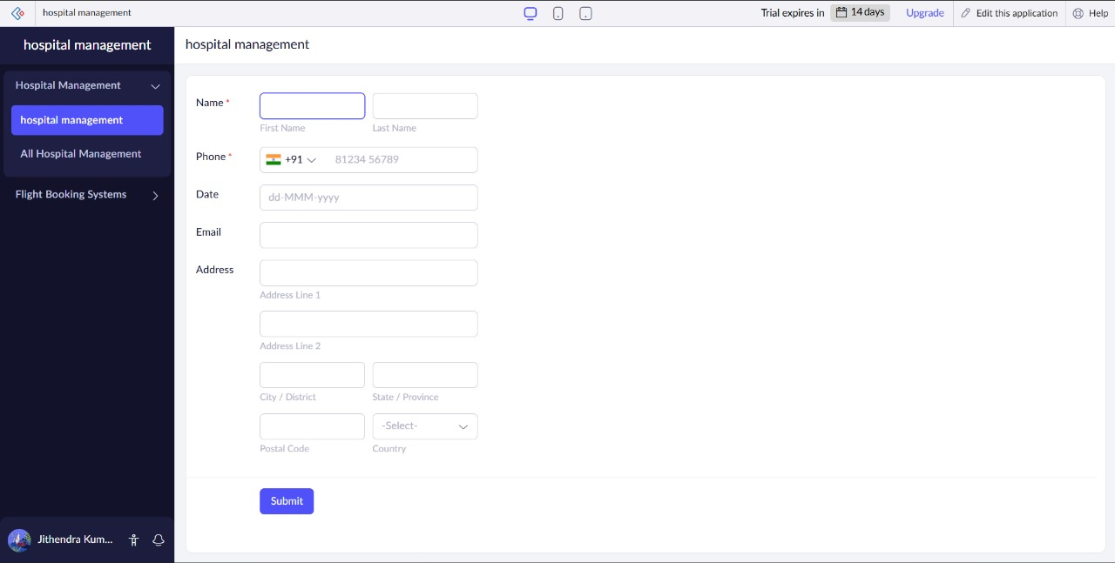
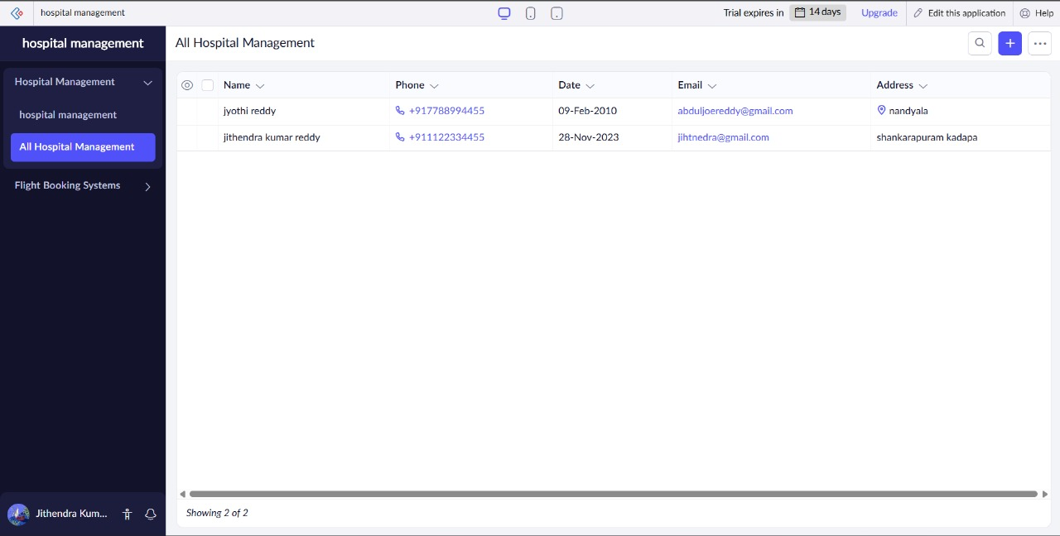
Result
A cloud-hosted application was successfully created and accessed as a SaaS service.

